Asia-China-Coin-Spade-Round Foot- H 3.481 var R 4-Mould

obv. "离石" , rev. "三十五". height17 cm. / 6.69 in., width 5.3cm. /2.09 in., H 3.481 var R 4; Coole 3(1972):397, no. 4315 var.

离石三十五圆足布,The "Li Shi" City State, Round-Foot Spade-shape Coin."离石", place of the Zhao Nation, now the Li Shi City离石区, ShanXi Province."三十五"mark number. It was used in the Zhao Nation, middle or late warring sates period.

钱范, coin mould is more rare and precious than the coin itself because it was the bronze mould from which a ceramic mould was made and from which the coins were prodced..

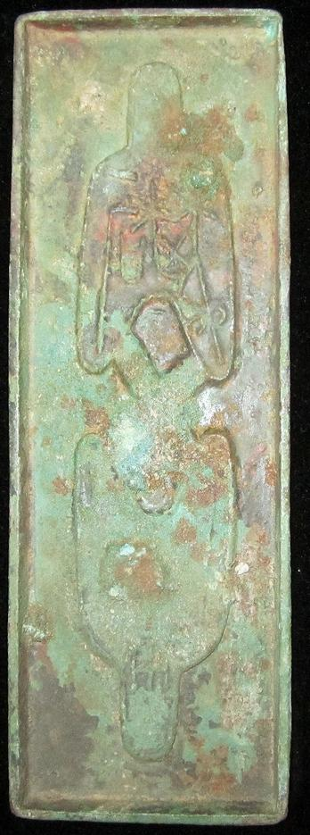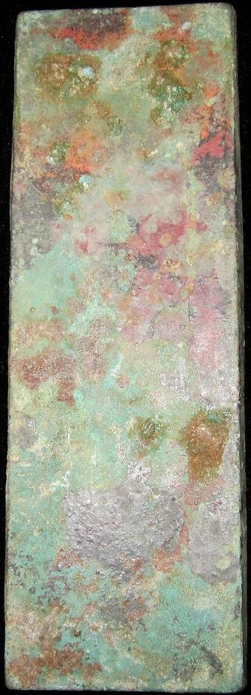

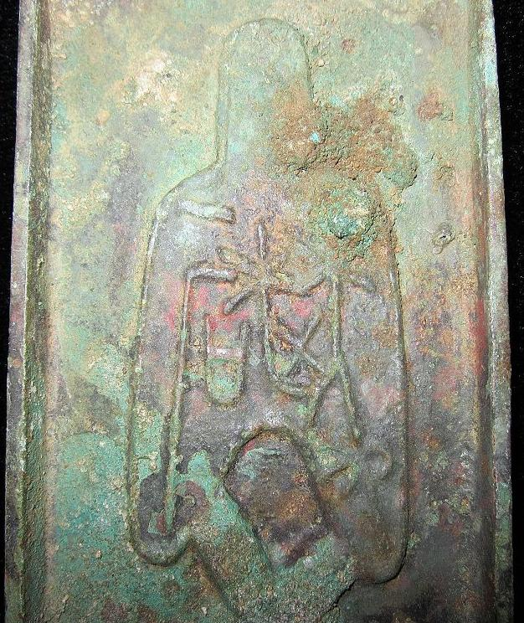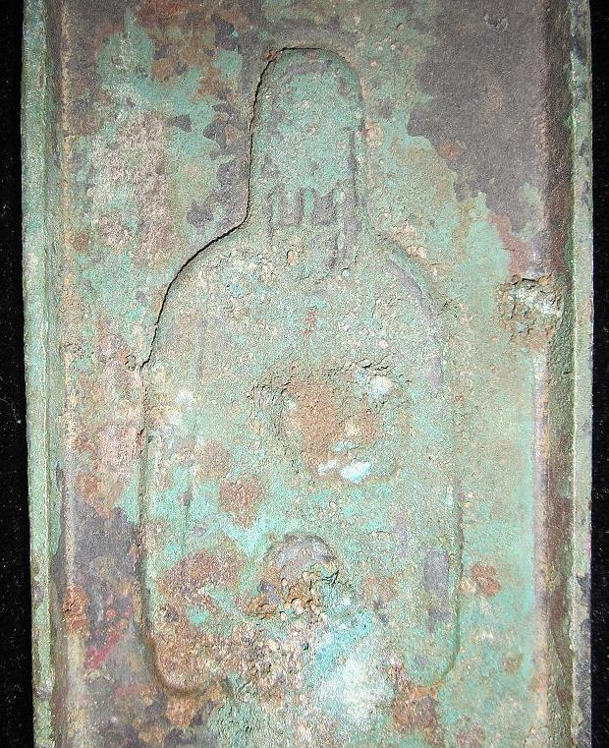

Order details Printer friendly page

Sold by

[bcculture](http://myworld.ebay.com/bcculture) ( [81](http://feedback.ebay.com/ws/eBayISAPI.dll?ViewFeedback&userid=bcculture)  )

+ Show additional actions

Delivery package 1 of 1

Estimated delivery Thursday, Jan 16, 2014 - Thursday, Feb 13, 2014

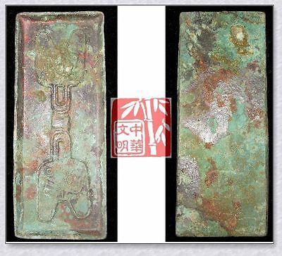

[WARRINGSTATESPERIOD ZHAO NATION MINT MONEY MODEL BRONZE SPADE COIN PATTERN晋阳圆足布](http://www.ebay.com/itm/251391146316)

Item price

$79.99

Quantity

1

Item number

251391146316

Shipping service

Economy Shipping from outside US

[Leave feedback](http://feedback.ebay.com/ws/eBayISAPI.dll?LeaveFeedbackShow&useridfrom=802-867&useridto=bcculture&item=251391146316&transactid=1359873001015) [Contact seller](http://contact.ebay.com/ws/eBayISAPI.dll?FindAnswers&frm=3998&iid=251391146316&redirect=0&requested=bcculture) [Return item](http://return.ebay.com/ws/eBayISAPI.dll?ResolveReturn&eventName=viewSelectedItem&TransactionId=1359873001015&ItemId=251391146316)

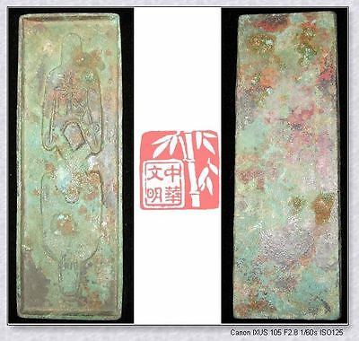

[WARRINGSTATESPERIOD ZHAO CITY MINT MONEY MODEL BRONZE SPADE COIN PATTERN离石三十五圆足布](http://www.ebay.com/itm/251391204570)

Item price

$79.99

Quantity

1

Item number

251391204570

Shipping service

Economy Shipping from outside US

[Leave feedback](http://feedback.ebay.com/ws/eBayISAPI.dll?LeaveFeedbackShow&useridfrom=802-867&useridto=bcculture&item=251391204570&transactid=1359907380015) [Contact seller](http://contact.ebay.com/ws/eBayISAPI.dll?FindAnswers&frm=3998&iid=251391204570&redirect=0&requested=bcculture) [Return item](http://return.ebay.com/ws/eBayISAPI.dll?ResolveReturn&eventName=viewSelectedItem&TransactionId=1359907380015&ItemId=251391204570)

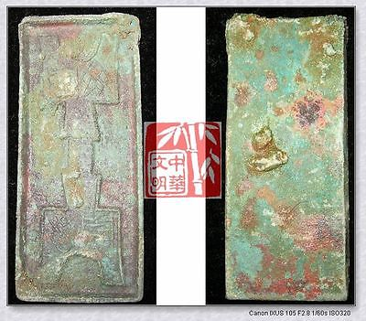

[WarringStatesPeriod WEI CITY MINT MONEY MODEL BRONZE SPADE COIN PATTERN阴晋桥足布RARE](http://www.ebay.com/itm/251412498472)

Item price

$49.99

Quantity

1

Item number

251412498472

Shipping service

Economy Shipping from outside US

[Leave feedback](http://feedback.ebay.com/ws/eBayISAPI.dll?LeaveFeedbackShow&useridfrom=802-867&useridto=bcculture&item=251412498472&transactid=1359874723015) [Contact seller](http://contact.ebay.com/ws/eBayISAPI.dll?FindAnswers&frm=3998&iid=251412498472&redirect=0&requested=bcculture) [Return item](http://return.ebay.com/ws/eBayISAPI.dll?ResolveReturn&eventName=viewSelectedItem&TransactionId=1359874723015&ItemId=251412498472)

### Shipping address

Ralph J Coffman Jr  
149 Atlantic Ave   
Swampscott MA 01907-2427  
United States

Phone number  
781 584 7091

### Order total

Subtotal $209.97

Shipping $95.00

Shipping discount -$6.00

#### Total

## $298.97

[View PayPal transaction](http://payments.ebay.com/ws1/eBayISAPI.dll?IntermediateResolutionInfo&itemid=0&transId=0&pn=UnifiedCheckoutSummaryRedirect2PP&qs=itemid%3D0%26transId%3D0%26buyerorseller%3D0%26)

### Order information

Order placed on  
Saturday, Dec 28, 2013

Having a problem with this purchase?  
[Resolve problem](http://res.ebay.com/ws/eBayISAPI.dll?ResolutionCenter)

Payment method   
PayPal

Payment date  
Saturday, Dec 28, 2013